**DEDUPLICATION :**

**CHALLENGES :**

* Rising storage costs due to unchecked data growth
* Exponential data growth and shrinking backup windows
* While dealing with same staffing levels
* Longer data retention on disk required for SLA’s and regulatory requirements
* Limited space, power, cooling, budget
* Data de-duplication technology can dramatically reduce physical disk capacity requirements while still meeting data storage requirements

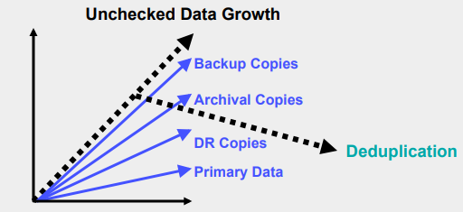

**APPLICATIONS(/ADVANTAGES) OF DEDUPLICATION :**

* **Remote offices:**De-duplication can help address a common situation for remote offices where there are no onsite skills to manage backups.
* **Data de-duplication and duplicate files:**Eliminating duplicate files is one of the most appealing [reasons for data de-duplication](http://searchstorage.techtarget.com/definition/data-deduplication).
* **Reduced media handling:**For environments still needing tape operators and racks to store media because the [tape library](http://searchdatabackup.techtarget.com/tip/How-to-choose-the-right-tape-library) is at near capacity, de-duplication offers a great opportunity to reduce media handling allowing resources to be redeployed in other areas where they are needed.
* **Space reclamation:** Given the cost of data center space, it may make a lot of sense to reclaim some of the space occupied by a very large tape library and replace it with some reduced footprint, dedupe-capable disk arrays.
* **Tape upgrade:**Any organization considering a tape technology update should seriously consider disk de-duplication. Where it does not necessarily make financial sense to rip and replace a tape subsystems that is still meeting requirements, the need for a technology update always offers an opportunity to evaluate other options.

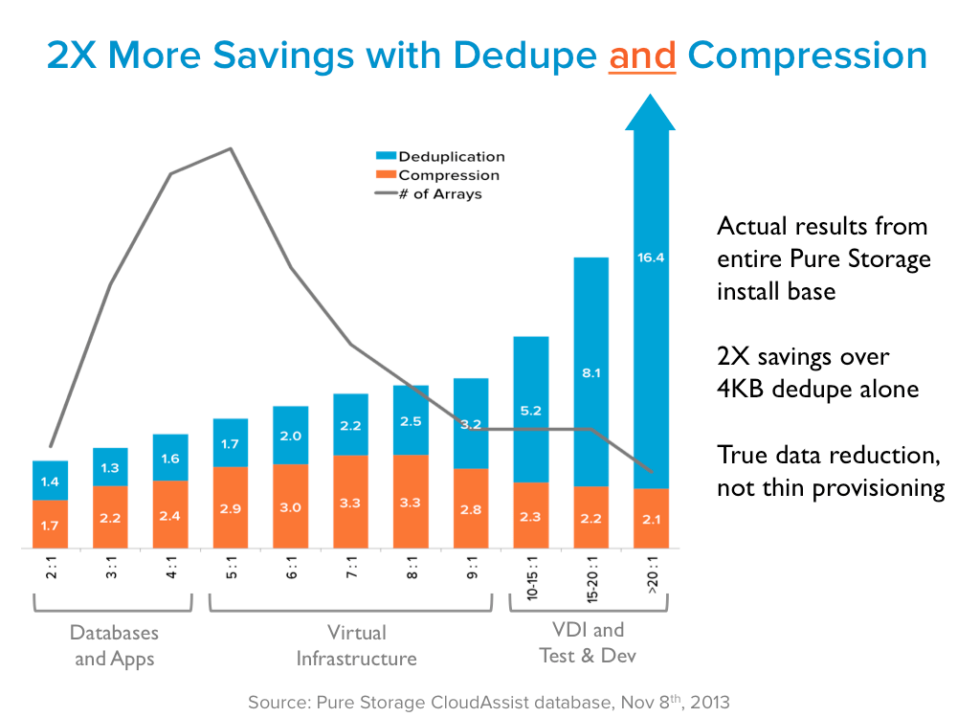

**USE CASE :**

* Consider an email server that contains 100 instances of the same 1 MB file attachment, say, a sales presentation with graphics that was sent to everyone on the global sales staff. Without data duplication, if everyone backs up his email inbox, all 100 instances of the presentation are saved, requiring 100 MB storage space. With data de-duplication, only one instance of the attachment is actually stored; each subsequent instance is just referenced back to the one saved copy, reducing storage and bandwidth demand to only 1 MB.
* <https://www.w3.org/2005/Incubator/lld/wiki/Use_Case_Identification_And_Deduplication_Of_Library_Records>
* <https://www.techrepublic.com/blog/the-enterprise-cloud/windows-server-8-deduplication-use-cases-and-caveats/>
* <http://ieeexplore.ieee.org/document/7936577/>
* <http://ieeexplore.ieee.org/document/6550860/>

**Useful Links :**

<http://blog.mirketa.com/top-five-deduplication-apps-on-salesforce-appexchange/>

<http://searchdatabackup.techtarget.com/tip/Data-deduplication-technology-The-business-case-for-dedupe>

<https://www.snia.org/sites/default/files/Dedupe_Business_Value_V5.pdf>

<http://www.computerweekly.com/tip/Where-to-use-data-deduplication-technology>